Project Organization
The project will be supported by a mix of qualify people on site who will be supported by the central team. A simple organization chart, in which the local roles are shown in green and the central support roles in blue, and summary of the key job roles are provided below.
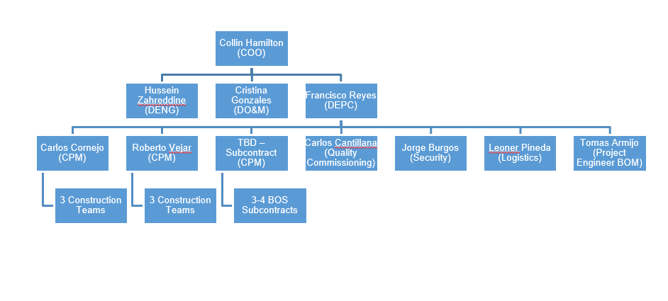
Construction Project Manager
- Manage the contractual relationship with the customer
- Monitor construction progress, identify issues which may impact the schedule and provide leadership to identify solutions
- Provide Monthly report and schedule updates
Site Manager
- Manage subcontractors on site, ensure all workers are aware of the site policies and that the appropriate documentation is in place prior to embarking on new tasks
- Monitor changing conditions and interpret necessary changes to procedures & processes as required
- Ensure that the latest revisions of documentation are always used
- Inspect works being carried out and verify that this is in accordance with the agreed documentation
- Internal reporting
Health, Safety and Environment Manager
- Develop a site specific health, safety and environmental plan, ensuring that all of the processes are in place to meet all applicable Company and local regulations
HSE Supervisor
- Hold weekly H&S meeting and provide reports
- Follow up on HSE issues raised and ensure efficient closure
- Ensure that all HSE activities are in accordance with local legislation and relevant documentation is provided
- Assess Health, Safety & Environmental Risks and ensure that contractor RAMs are appropriate for the tasks
- Ensure contractor documentation is up to date and follow up on discrepancies
Quality Control Manager
- Develop a site specific quality control plan, ensuring that all of the processes are in place to meet all applicable Company and local regulations
Quality Control Supervisor
- Follow up on Quality issues from the engineering phase throughout the construction phase.
- Ensure that all Quality activities, inspections, commissioning are carried out in accordance with contractual requirements
- Audit contractors and equipment putting effective measures into place to ensure that expectations are met.
Engineering Project Manager
- Responsible of the development of the Engineering
- Follow up construction issues related with engineering.
Procurement Manager
- Responsible of procurement of main equipment
Logistic & Shipping Responsible
- Responsible importation and transportation of main equipment.
Documentation Controller
- Manage the approval process of technical documentation and issue of documentation for construction purposes
- Ensure effective documentation control

